Experiment 6: Project Documentation and Progress Tracking using Confluence
Course code: CSA1006
Course: Software Engineering
Name: B. Pavani
Register No: 192525248
Tool Used: Confluence and Jira

Aim
To create a project overview page in Confluence for the Library Management System, list the project tasks, and link Jira issues on the page so that the project progress can be tracked in one place.

Software Used
Confluence and Jira Software (Atlassian cloud, free plan), https://www.atlassian.com

Procedure

Step 1: Log in to Confluence
Open the Atlassian site in a browser, log in with your Atlassian account and open Confluence from the app switcher.

Step 2: Create a new page
Click "Create" at the top and choose "Page". Enter the page title "Library Management System Project Overview".

Step 3: Add the project description
Under the heading "Project Description", write a short description: the Library Management System helps users search for books, log in securely, reserve books online, generate monthly borrowing reports and receive email notifications for overdue books.

Step 4: List the Jira tasks
Add the heading "Jira Tasks" and write the five project tasks as a numbered list: (1) Develop book search functionality, (2) Create user login page, (3) Implement online book reservation, (4) Generate monthly borrowing reports, (5) Send overdue book email notifications.
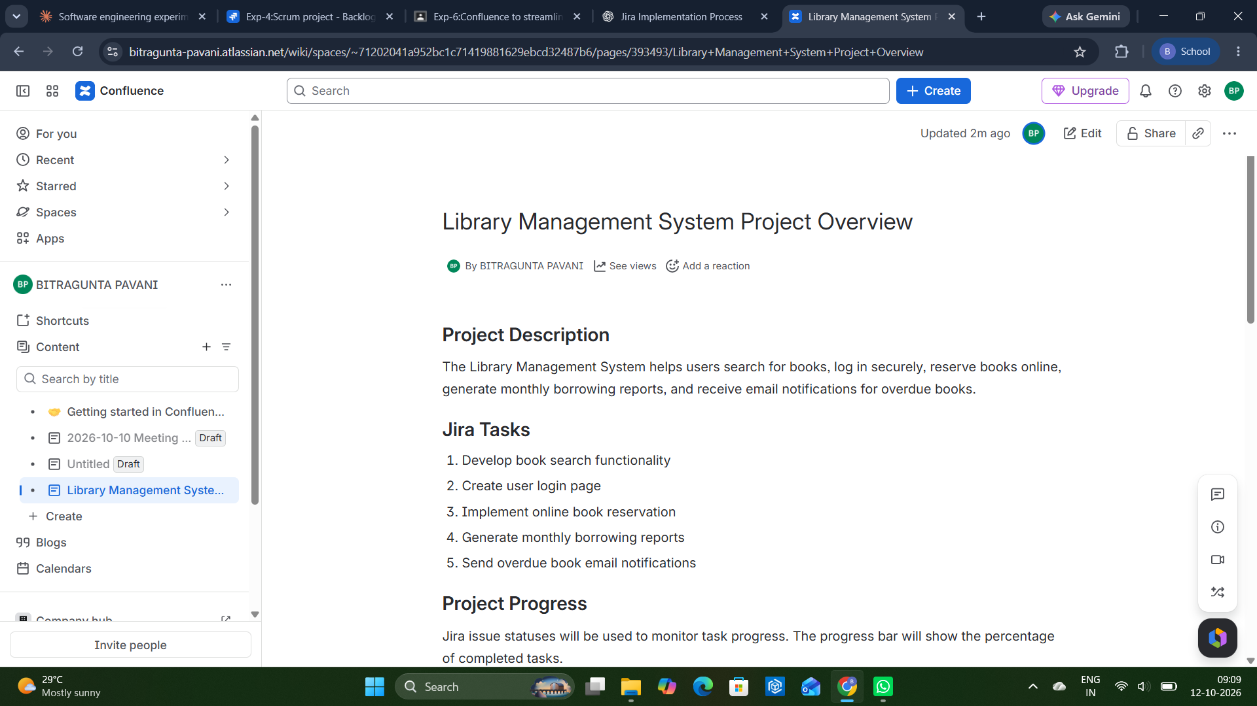
Figure 1: Confluence page with the project description, Jira tasks and project progress heading

Step 5: Link the Jira issues on the page
Under the heading "Project Progress", type /jira and choose the Jira issues macro. Select the Jira issues of the project. Confluence shows each issue with its type, key, summary, assignee, priority, status and last updated time, and keeps them synced with Jira.
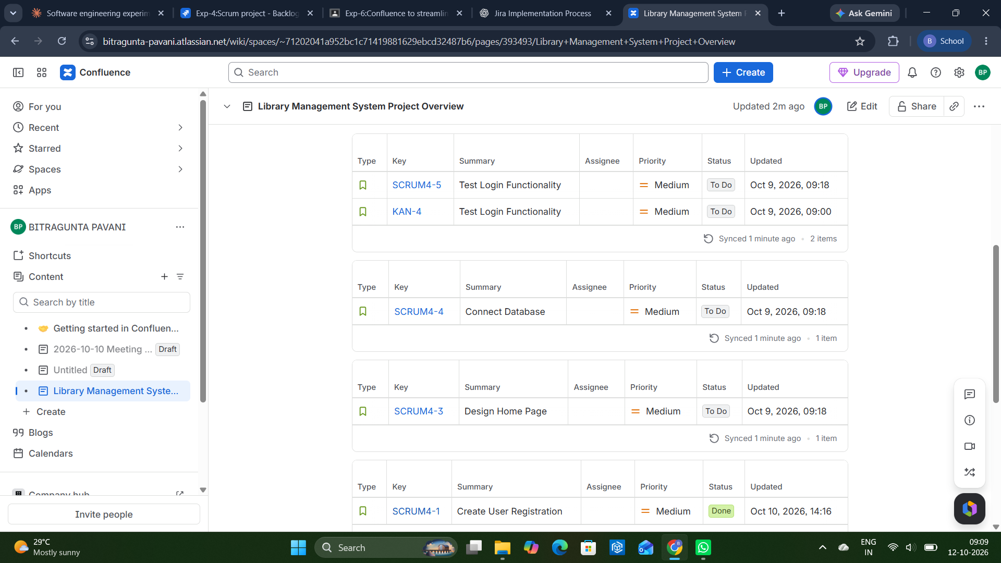
Figure 2: Jira issues linked on the Confluence page with their status
Issue | Summary | Status | Updated
SCRUM4-5 | Test Login Functionality | To Do | Oct 9, 2026, 09:18
KAN-4 | Test Login Functionality | To Do | Oct 9, 2026, 09:00
SCRUM4-4 | Connect Database | To Do | Oct 9, 2026, 09:18
SCRUM4-3 | Design Home Page | To Do | Oct 9, 2026, 09:18
SCRUM4-1 | Create User Registration | Done | Oct 10, 2026, 14:16
SCRUM4-2 | Develop API for Login | In Progress | Oct 10, 2026, 14:16

Step 6: Show the project completion
Below the linked issues, add the line "Project Completion: 20% (1 out of 5 tasks completed)" and a simple progress bar. One task is Done out of five, so the completion is 1 / 5 = 20%.
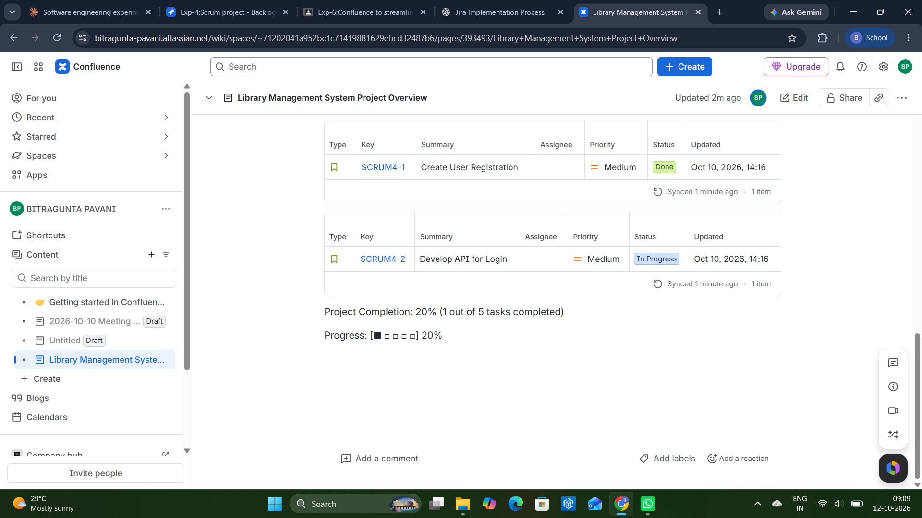
Figure 3: Project completion and progress bar on the Confluence page

Step 7: Save the page
Click "Update" (or "Publish") to save the page. The Jira issues on the page refresh automatically when their status changes in Jira.

Result
A project overview page for the Library Management System was created in Confluence. It contains the project description, the list of Jira tasks, the linked Jira issues with their live status, and the project completion of 20% (1 out of 5 tasks completed). This gives the team one place to document the project and track its progress.

